#####Page break

## General Health

###Summary

**For the most recent time periods available3, Moray HSCP had:**

* An average life expectancy of **78.7** years for males and **82.1** years for females, compared to the national average of 76.5 and 80.7 years of age respectively.
* A death rate for ages 15 to 44 of **106** deaths per 100,000 age-sex standardised population. This is lower than Scotland (117 deaths per 100,000)4.
* **23.3%** of the HSCP’s population with at least one long-term physical health condition. This is higher than Scotland (21.7%).
* A cancer registration rate of **600** registrations per 100,000 age-sex standardised population (compared to 630 in Scotland), and an early deaths (<75 years) from cancer rate of **138** per 100,000 age-sex standardised population (compared to 150 in Scotland)4.
* **18.6%** of the population being prescribed medication for anxiety, depression, or psychosis. This is a smaller proportion than Scotland (20.1%).

###Life Expectancy

In the latest time period available from 2020 - 2022 (5-year aggregate), the average life expectancy in Moray HSCP was 78.7 years of age for men, and 82.1 years of age for women. A 10-year time trend can be seen in figure 1.

####Figure 1: Average life expectancy in men and women over time.

## filter: removed 1,684 rows (29%), 4,142 rows remaining

## filter: removed 3,898 rows (94%), 244 rows remaining

## right_join: added 4 columns (hscp2019name, hscp2019, hb2019name, hb2019)

## > rows only in x ( 14)

## > rows only in y 11

## > matched rows 230 (includes duplicates)

## > =====

## > rows total 241

## filter: removed 230 rows (95%), 11 rows remaining

## select: dropped 16 variables (indicator, area_code, area_type, year, period, …)

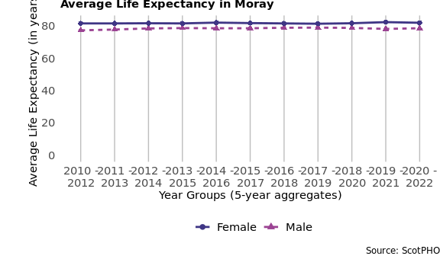

#####Page break

Table 1 provides the average life expectancy for men and women in different areas for the latest time period available.

####Table 1: Average life expectancy in years for the latest time periods (2020 - 2022 aggregated years for the HSCP; 2020 - 2022 aggregated years for other areas).

| Sex | Moray | NHS Grampian | Scotland |
| --- | --- | --- | --- |
| Female | 82.1 | 81.6 | 80.7 |
| Male | 78.7 | 77.3 | 76.5 |

###Deaths, aged 15-44 The following chart shows a trend of death rates among 15-44 year olds per 100,000 age-sex standardised population4 by area. In the most recent aggregate time period available (2019 - 2021), the mortality rate in Moray HSCP was **106** deaths per 100,000 population.

####Figure 2: Deaths aged 15-44 years by geographical area and over time.

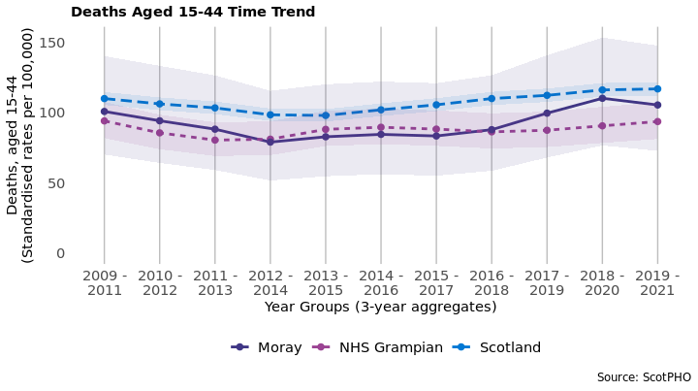

#####Page break

Figure 3 provides comparisons of deaths at ages 15-44 between Moray HSCP and Scotland. In 2019 - 2021, Moray had a lower rate than the rest of Scotland (106 compared to 117 deaths per 100,000).

####Figure 3: Deaths at ages 15-44 by area for the latest time period available.

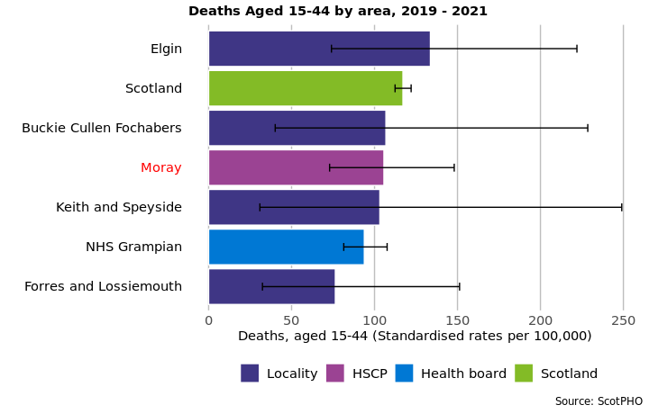

#####Page break ###Long-Term Physical Health Conditions and Multimorbidity

In the financial year 2022/23, in Moray HSCP, it is estimated that **23.3%** of the population had at least one physical long-term condition (LTC). These include: cardiovascular, neurodegenerative, and respiratory conditions, as well as other organ conditions (namely liver disease and renal failure), arthritis, cancer, diabetes, and epilepsy. *Please note that estimates for this section are based on people who had contact with NHS services - see footnotes for further information and caveats on identifying LTCs.5*

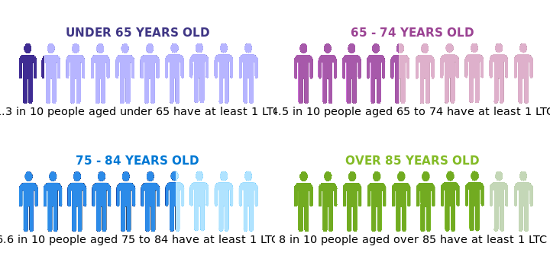

The co-occurrence of two or more conditions, known as multimorbidity, is broken down in table 2, distinguishing between age groups. Overall, **2.6**% of those under the age of 65 have more than one LTC, compared to **30.2**% of those aged over 65.

####Table 2: Multimorbidity of physical long-term conditions by age group in 2022/23.

|  | Proportion over 65 (%) | Proportion under 65 (%) |
| --- | --- | --- |
| 1 LTC | 26.7 | 10.7 |
| 2 LTCs | 15.3 | 1.9 |
| 3 LTCs | 8.0 | 0.5 |
| 4 or more LTCs | 6.9 | 0.2 |

#####Page break **Most common physical Long-Term Conditions (LTCs)**

Below is a breakdown of the physical LTCs, for the financial year 2022/23. Figure 4 shows the prevalence of different LTCs in each age group in Moray HSCP, and Table 3 illustrates the top 5 physical LTCs across all ages at partnership, and Scotland level.

####Figure 4: Percentage people with each physical LTC, split by age group.

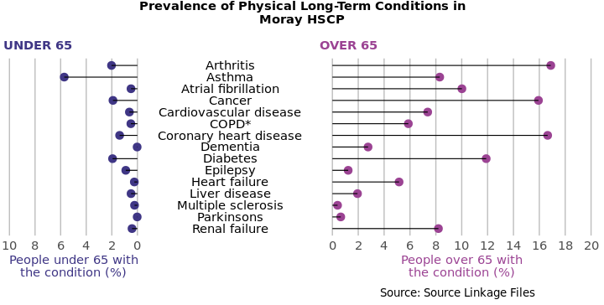

######*COPD: Chronic Obstructive Pulmonary Disease

####Table 3: Prevalence of the five most common physical LTCs as a percentage of the population across geographical areas (where 1 = most prevalent).

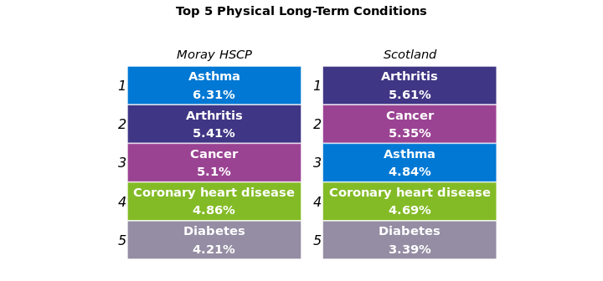

###Cancer For the period 2019 - 2021, there were **630** new cancer registrations per year on average (**600** registrations per 100,000 age-sex standardised population) in Moray HSCP. For the period 2019 - 2021, there were also **138** early deaths per 100,000 from cancer in the HSCP, this is a **5.7%** decrease compared to the rate 10 years prior.

####Figure 5: Cancer registration rate over time and by area.

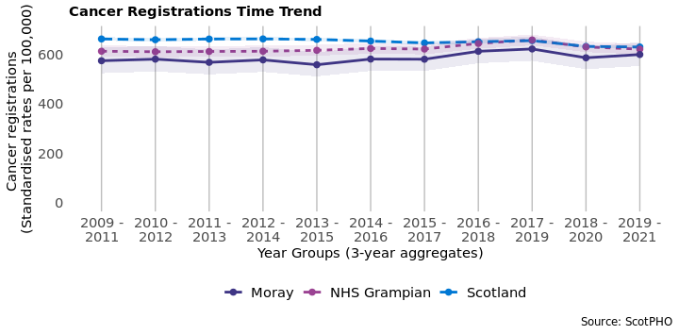

####Figure 6: Early deaths from cancer (<75 years) over time and by area.

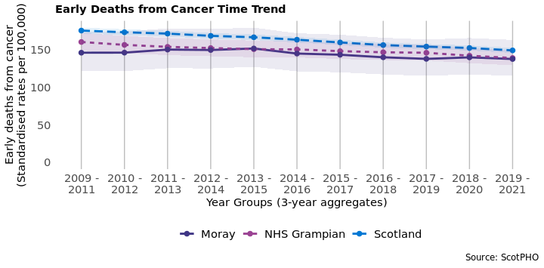

#####Page break

### Hospitalisations by condition

Patient hospitalisations can provide some indication of how certain diseases have varying impacts on people’s lives. In the latest time period available in Moray, the condition with the highest rate of hospitalisations was Coronary Heart Disease.

#### Table 4: Patient hospitalisations by condition and geographical area, age-sex standardised rates per 100,000.

| Disease | Latest time period | Moray | NHS Grampian | Scotland |
| --- | --- | --- | --- | --- |
| Asthma | 2019/20 - 2021/22 | 52.2 | 41.7 | 68.4 |
| COPD | 2019/20 - 2021/22 | 118.6 | 140.1 | 207.5 |
| Coronary Heart Disease | 2019/20 - 2021/22 | 329.9 | 319.7 | 341.6 |

###Anxiety, Depression, and Psychosis prescriptions

In 2021/22, **18.6%** of people were prescribed medication for anxiety, depression, or psychosis in Moray HSCP. This is a **39.5% increase** from the rate 10 years prior in 2011/12.

####Figure 7: Anxiety, depression, and psychosis prescriptions over time and by geographical area.

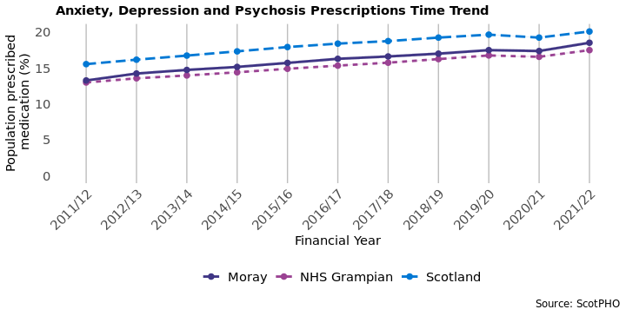

#####Page break

In 2021/22, Moray had a smaller proportion of the population being prescribed ADP medication compared to the rest of Scotland (18.6% compared to 20.1%).

####Figure 8: Percentage population prescribed medication for anxiety, depression, and psychosis by area for the latest time period available.

